Test Doc

1. Tests TuitionDue() on both full-time and part-time students with no funding.
   1. Input

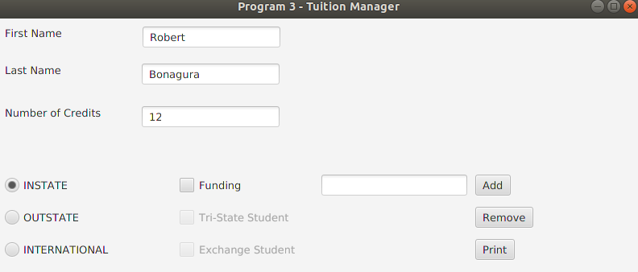

Tuition Due: 6637

* 1. Input

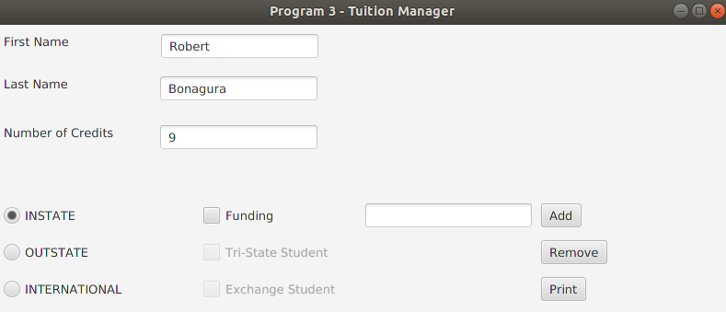

Tuition Due: 4743

1. Test if Student is taking a valid number of credits.
   1. Valid examples are shown in test case 1
   2. Invalid example Input

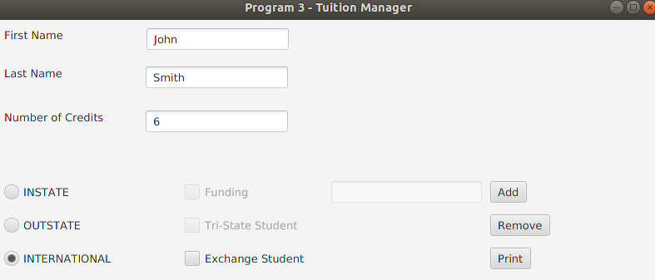

Output: “Error: International students must have at least 9 credits.”

1. 0 or negative value for number of credits or funding amount.
   1. Input

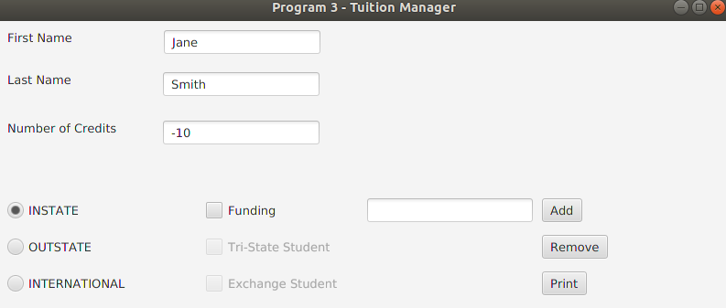

Output: “Error: Student must have a positive number of credits.”

* 1. Input

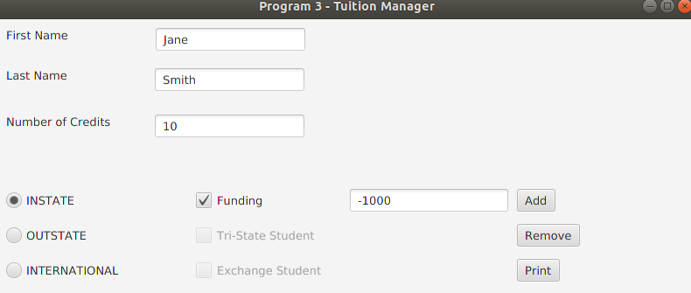

Output: “Error: Funding needs to be a positive value.”

1. Characters are entered where integers are expected
   1. Input

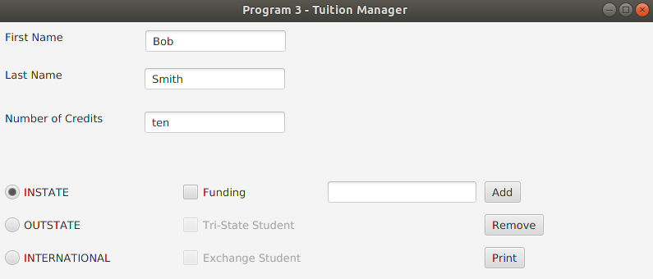

Output: “Error: Fields requiring a number value cannot be given a character value.”

1. Clicking ‘Add’ or ‘Remove’ buttons when no data has been entered.
   1. Output: “Error: Student name fields cannot be left blank or contain only white spaces.”